Pay statements are viewable in ADP via SuccessFactors.

Accessing SuccessFactors
Click Employee Launchpad (SAP SuccessFactors) from https://www.purdue.edu/hr/global/index.php
- Log in using Purdue Career Account ID and Password.

Locate and click the ADP tile | 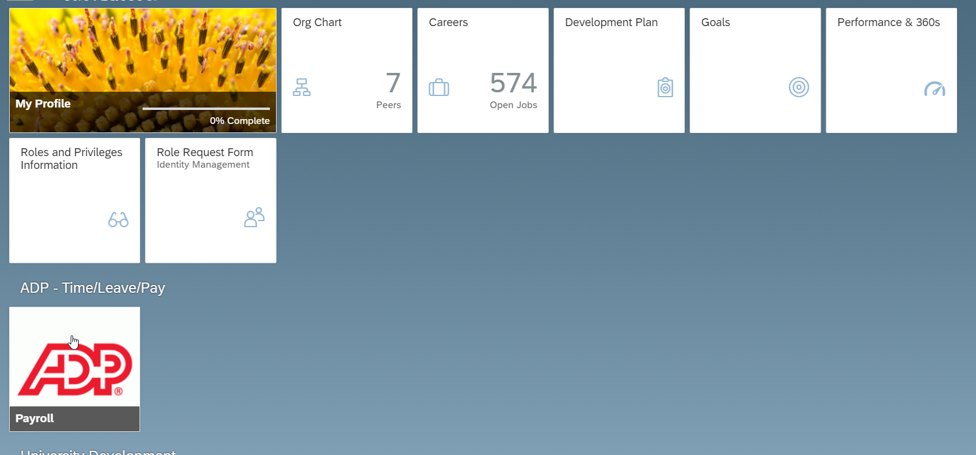

Review Pay Statements
Click Myself | 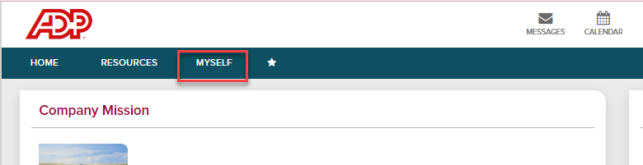
Click Pay  Select Pay Statements | 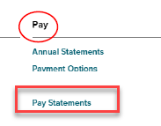  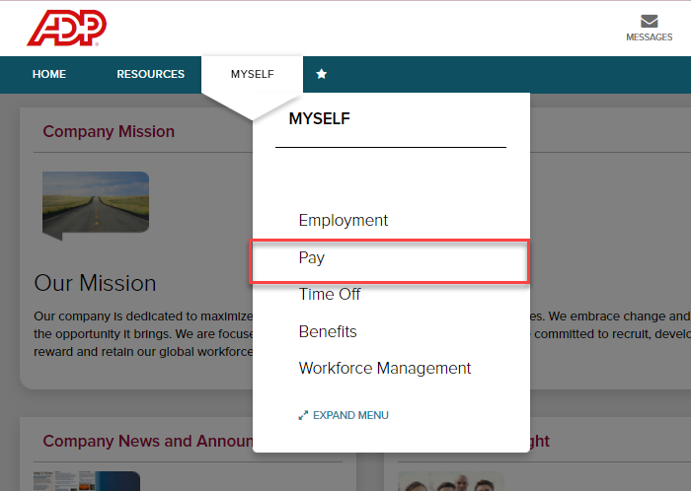
If you want to view your personal and pay detail information, click the blue arrow next to your name.  - You can access your pay statements for three years.  - All available pay statements display. | 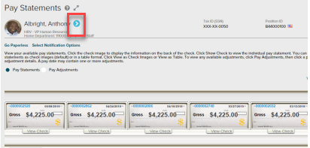
To view your statements from a check image, click View Check.  - You can also view net pay detail and amounts for a check when you click the check image | 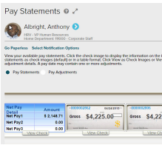
To view any pay adjustments that may have been made to your pay, do the following:  - From the Pay Statements page, click Pay Adjustments  - To see more detail about a specific adjustment, click the Pay Date for that adjustment. | 